Multiple choice section

|  |  |  |  |  |  |  |  |  |
| --- | --- | --- | --- | --- | --- | --- | --- | --- |
| Question | 1 | 2 | 3 | 4 | 5 | 6 | 7 | 8 |
| Answer | A | D | C | D | B | C | B | A |

Question 1 [7.1]

A

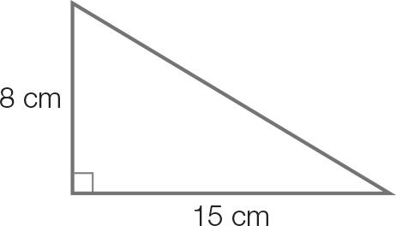

Use Pythagoras’ theorem to find the length of the diagonal.

x2 = 82 + 152

x2 = 64 + 225

x2 = 289

x = 

x = 17 cm

Question 2 [7.1]

D

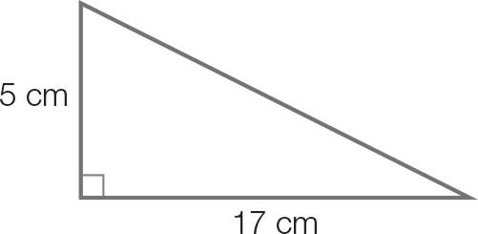

Use Pythagoras’ theorem to find the length of the diagonal.

x2 = 172 + 52

x2 = 289 + 25

x2 = 314

x = 

x = 17.72…

x = 18 cm (correct to the nearest whole number)

Question 3 [7.2]

C

sin (235) = sin (180 + 55)

= −sin (55)

Question 4 [7.2]

D

Amplitude = (3 – (-3))= 3 Period = 360

Question 5 [7.3]

B



In the 1st quadrant, x = tan-1 (1) = 45 In the 3rd quadrant, x = 180 + 45 = 225

Question 6 [7.4]

C

Use the sine rule:

 = 

x = 

Question 7 [7.6]

B

Label the triangle using A, a, B, b, C and c.

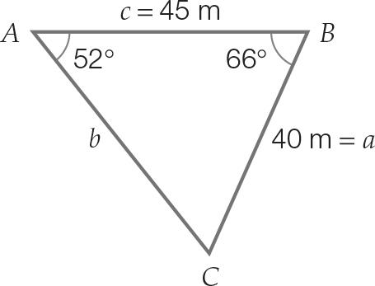

**A** *b*2 = 402 + 452 – 2 × 40 *×* 45 *×* cos(66°): this equation can be used to find side length *b*.

**B** Area = ½ × 40 × 45 × 52°: this is incorrect. Area = ½ × 40 × 45 × sin(66.

**C** : this equation could also be used to find side length *b*.

**D** *****ACB* = 180° − (52° + 66°): this equation can be used to calculate the missing angle *C*.

Question 8 [7.6]

A

A = ab sin (θ) =  × 5 × 4 × sin (30) = 5 cm2

Multiple-choice total marks: 8

Short answer section

Question 9 4 marks [7.1]

(a)

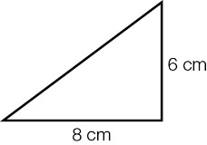  
Length of diagonal = 10 cm (6, 8, 10 Pythagorean triple)

(b)

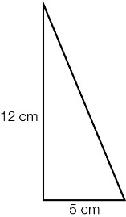  
Length of sloping edge using half the diagonal and the height = 13 cm   
(5, 12, 13 Pythagorean triple)  
sin (angle required) =   
angle required = sin-1    
angle required = 67.38…  
angle required = 67 (closest to the nearest degree)

Question 10 2 marks [7.1]

Let r be the radius.





Question 11 2 marks [7.1]

Length of diagonal BC = 

BC = 25 cm

tan (θ) = 

= 1

Angle with base = tan-1(1)

= 45

Question 12 2 marks [7.2]

(a) sin (132) = sin (180 − 132)  
= sin (48)

(b) tan (314) = tan (360 − 314)  
= −tan (46)

Question 13 2 marks [7.3]

sin (x) = 

In the 1st quadrant, sin (x) is positive.

In the 2nd quadrant, sin (x) is positive.

sin (x) is negative in quadrants 3 and 4.

Therefore the solutions will be found in both the 1st and 2nd quadrants.

Question 14 2 marks [7.2]

cos (φ) is negative in the 2nd and 3rd quadrants

−cos (30) = cos (180 − 30) or cos (180 + 30)

= cos (150) or cos (210)

φ = 150 or 210

Question 15 2 marks [7.3]

1.2 × tan (θ) = −4.2

1.2 × tan (θ) = −1.2

tan (θ) = −1

tan (θ) is negative in the 2nd and 4th quadrants.

In the 2nd quadrant, θ = (180 − 45) = 135

Question 16 4 marks [7.4]

(a) c2 = a2 + b2 – 2ab cos (θ)  
782 = 842 + 932 – 2 × 84× 93 × cos (θ)  
6084 = 15 705 – 15 624 × cos (θ)  
−9621 = –15 624 × cos (θ)  
cos (θ) =    
θ = cos-1   
θ = 51.991…  
θ = 52 (correct to the closest degree)

(b) The sine rule can be used to calculate the second angle.  
   
B = 58.062…  
B = 58 (correct to the nearest degree)  
To find the third angle, subtract the two known angles from 180.  
C = 180 − (52 + 58)  
C = 70

Question 17 6 marks [7.5]

(a) ϕ = 45  
θ = (180 − 45)  
 = 135

(b) Use cosine formula.  
Let x be the length AC  
x2 = 202 + 102 – 2 × 20 × 10 × cos (135)  
 = 400 + 100 – 400 cos (135)  
  
 x = 27.979 km

(c) Distance saved = 20 + 10 – 27.979  
= 2.021 km  
= 2021 m

Question 18 2 marks [7.6]

Area =  × 36 × 43 × sin (154)

= 339.30 cm2

Short answer total marks: 28

Extended response section

Question 19 8 marks [7.6]

(a)

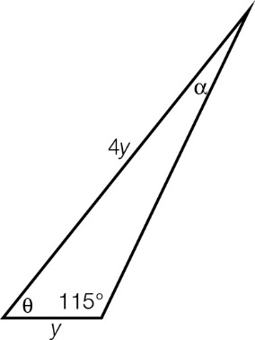

(b)   
  
Therefore the angle included, θ = 180 – (115 + 13) = 52.

(c) Area =  × y × 4y × sin (52)

(d) 69 500 = 2 sin (52) × y2   
y2 = 44 098.38  
y = 209.99  
= 210 m

Question 20 10 marks [7.6]

(a) Using Pythagoras’ theorem:  
Length BD =   
= 90 m

(b) Let θ = ∠BDC   
tan (θ) =   
θ = 36.87  
θ = 37  
∠CBD = 53

(c) ∠ABD = 130 – ∠CBD  
 = 76.87   
∠ADB = 135 – ∠CDB  
 = 98.13  
  
AD =   
 = 86.57  
 = 87 m

(d) Area of ΔBCD =  × 54 × 72 = 1944 m2  
Area of ΔABD =  × 88 × 90 × sin (76.87) = 3856 m2  
Total area = 1944 + 3856 = 5803 m2

(e) Perimeter = 88 + 54 + 72 + 86.57  
 = 300.587 m  
Fencing length required = 301 m

Question 21 4 marks [7.2, 7.3]

(a) Period = 12 hours  
Amplitude = (1 – −3) = 2

(b) 8 pm Tuesday

Extended answer total marks: 22

TOTAL test marks: 58